**Markup Language (HTML)**

**MODULE 2**

**Introduction to HTML**

HTML is the standard markup language for creating Web pages.

* HTML stands for Hyper Text Markup Language
* HTML describes the structure of Web pages using markup
* HTML elements are the building blocks of HTML pages
* HTML elements are represented by tags
* HTML tags label pieces of content such as "heading", "paragraph", "table", and so on
* Browsers do not display the HTML tags, but use them to render the content of the page

## A Simple HTML Document

<html>  
 <head>  
 <title>Page Title</title>  
 </head>  
 <body>  
 <h1>My First Heading</h1>  
 <p>My first paragraph.</p>  
 </body>  
</html>

## Example Explained

* The <!DOCTYPE html> declaration defines this document to be HTML5
* The <html> element is the root element of an HTML page
* The <head> element contains meta information about the document
* The <title> element specifies a title for the document
* The <body> element contains the visible page content
* The <h1> element defines a large heading
* The <p> element defines a paragraph

## HTML Tags

HTML tags are element names surrounded by angle brackets:

<tagname>content goes here...</tagname>

* HTML tags normally come **in pairs** like <p> and </p>
* The first tag in a pair is the **start tag,** the second tag is the **end tag**
* The end tag is written like the start tag, but with a **forward slash** inserted before the tag name

## HTML Page Structure

Below is a visualization of an HTML page structure:

<html>

<head>

<title>Page title</title>

</head>

<body>

<h1>This is a heading</h1>

<p>This is a paragraph.</p>

<p>This is another paragraph.</p>

</body>

</html>

## HTML Headings

Headings are important in HTML documents. HTML headings are defined with the <h1> to <h6> tags.

<h1>This is a heading</h1>  
<h2>This is a heading</h2>  
<h3>This is a heading</h3>

## HTML Paragraphs

HTML documents are divided into paragraphs. HTML paragraphs are defined with the <p> tag.

<p>This is a paragraph.</p>  
<p>This is another paragraph.</p>

## HTML Elements

An HTML element is an individual component of an HTML document. It represents a semantics or meaning

**HTML Element Syntax**

An HTML element starts with a **start tag / opening tag**

An HTML element ends with an **end tag / closing tag**

The **element content** is everything between the start and the end tag

Some HTML elements have **empty content**

Empty elements are **closed in the start tag**

Most HTML elements can have **attributes**

<p class=’abc’> This is an Element </p>

**HTML Element Vs HTML Tag**

*HTML element* is a collection of starting tag, its attributes, an ending tag and everything in between

*HTML tag* is used to mark the start and end of an element

## HTML Formatting Elements

HTML also defines special **elements** for defining text with a special **meaning**.

HTML uses elements like <b> and <i> for formatting output, like **bold** or *italic* text.

Formatting elements were designed to display special types of text:

|  |  |
| --- | --- |
| * <b> | * Bold text |
| * <strong> | * Important text |
| * <i> | * Italic text |
| * <em> | * Emphasized text |
| * <mark> | * Marked text |
| * <small> | * Small text |
| * <del> | * Deleted text |
| * <ins> | * Inserted text |
| * <sub> | * Subscript text |
| * <sup> | * Superscript text |
| * <u> | * underline |

## HTML <b> and <strong> Elements

The HTML <b> element defines **bold** text, without any extra importance.

The HTML <strong> element defines **strong** text, with added semantic "strong" importance.

<b>This text is bold</b>

<strong>This text is strong</strong>

## HTML <i> and <em> Elements

The HTML <i> element defines italic text, without any extra importance.

The HTML <em> element defines emphasized text, with added semantic importance.

<i>This text is italic</i>

<em>This text is emphasized</em>

## Underlined Text

The text within <u>.........</u> element, is shown as underlined text.

<p> <u>Write Your First Paragraph in underlined text.</u></p>

## Monospaced Font

Each letter within <tt>.............</tt> element, has the same width.

<p>Hello <tt>Write Your First Paragraph in monospaced font.</tt></p>

## HTML <small> Element

The HTML <small> element defines smaller text:

<h2>HTML <small>Small</small> Formatting</h2>

## HTML <mark> Element

The HTML <mark> element defines marked or highlighted text:

<h2>HTML <mark>Marked</mark> Formatting</h2>

## HTML <del> Element

The HTML <del> element defines (removed) text.

<p>My favorite color is <del>blue</del> red.</p>

## HTML <ins> Element

The HTML <ins> element defines inserted (added) text.

<p>My favorite <ins>color</ins> is red.</p>

## HTML <sub> Element

The HTML <sub> element defines subscripted text.

<p>This is <sub>subscripted</sub> text.</p>

## HTML <sup> Element

The HTML <sup> element defines superscripted text.

<p>This is <sup>superscripted</sup> text.</p>

**Example**

<html>

<body>

<b>This text is bold</b> <br/>

<strong>This text is strong</strong> <br/>

<i>This text is italic</i> <br/>

<em>This text is emphasized</em> <br/>

<p> <u>Write Your First Paragraph in underlined text.</u></p>

<p>Hello <tt>Write Your First Paragraph in monospaced font.</tt></p>

<h2>HTML <small>Small</small> Formatting</h2>

<h2>HTML <mark>Marked</mark> Formatting</h2>

<p>My favorite color is <del>blue</del> red.</p>

<p>My favorite <ins>color</ins> is red.</p>

<p>This is <sub>subscripted</sub> text.</p>

<p>This is <sup>superscripted</sup> text.</p>

</body>

</html>

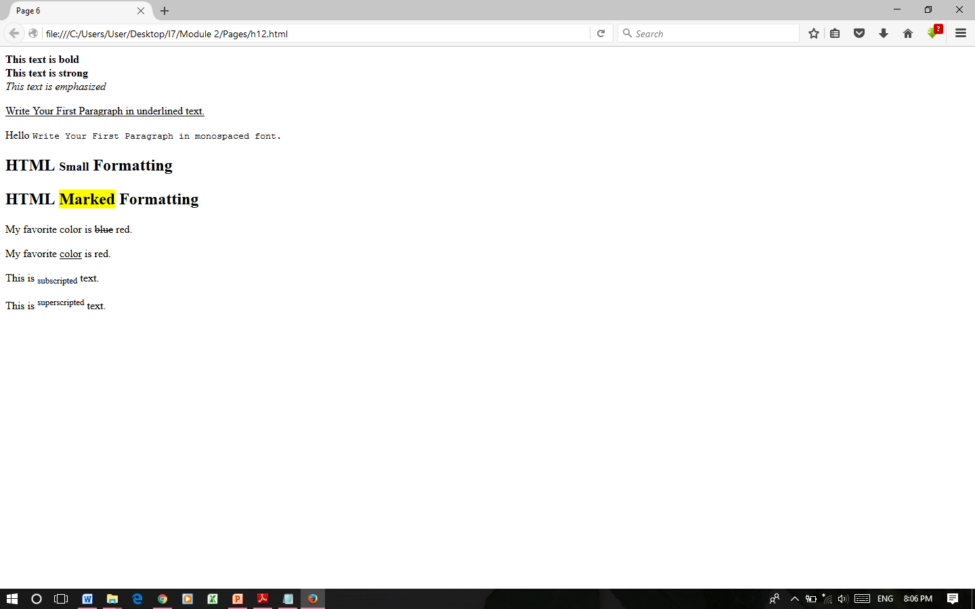

**HTML FONT ELEMENT**

Fonts play a very important role in making a website more user friendly and increasing content readability. Use HTML **<font>** tag to add style, size, and color to the text on your website. The font tag is having three attributes called **size, color**, and **face** to customize your fonts. To change any of the font attributes at any time within your webpage, simply use the <font> tag.

## Set Font Size

You can set content font size using **size** attribute. The range of accepted values is from 1(smallest) to 7(largest). The default size of a font is 3.

## Setting Font Face

Font face attribute uses to change the *face* of the text. But be aware that if the user viewing the page doesn't have the font installed, they will not be able to see it. Instead user will see the default font face applicable to the user's computer.

## Setting Font Color

You can set any font color you like using *color* attribute. You can specify the color that you want by either the color name or hexadecimal code for that color.

## The <basefont> Element

The <basefont> element is supposed to set a default font size, color, and typeface for any parts of the document that are not otherwise contained within a <font> tag.

### Example

Specify the font size, font face and color of text:

<html>

<body>

<p><font size=“5”>To show font SIZE</font></p>

<p><font color=“green”> The font color is Green</font></p>

<p><font face=“Verdana”> New Font Face </font></p>

<p><basefont color=“red” face=“Geneva” size=“12”> </p>

</body>

</html>

## HTML Comment

Comment is a piece of code which is ignored by any web browser. It is a good practice to add comments into your HTML code, especially in complex documents, to indicate sections of a document, and any other notes to anyone looking at the code. Comments help you and others understand your code and increases code readability.

HTML comments are placed in between **<!-- ... -->** tags. So, any content placed with-in <!-- ... --> tags will be treated as comment and will be completely ignored by the browser.

Comment tags are used to insert comments in the HTML source code.

<!-- Write your comments here -->

# HTML Image

**HTML img tag** is used to display image on the web page. HTML img tag is an empty tag that contains attributes only, closing tags are not used in HTML image element.

The <img> tag is an empty tag, which means that, it can contain only list of attributes and it has no closing tag.

Let's see an example of HTML image.

<h2>HTML Image Example</h2>

<img src="good_morning.jpg" alt="Good Morning Friends"/>

## Html Background

By default, your webpage background is white in color. HTML provides you following two good ways to decorate your webpage background.

* HTML Background with Colors
* HTML Background with Images

## Html Background with Colors

The **bgcolor** attribute is used to control the background of an HTML element, specifically page body and table backgrounds.

Following is the syntax to use bgcolor attribute with any HTML tag.

<tagname bgcolor = "color_value"...>

# HTML Links

Links allow users to click their way from page to page.

**HTML Hyperlinks (Links)**

A hyperlink (or link) is a word, group of words, or image that you can click on to jump to a new document or a new section within the current document.

When you move the cursor over a link in a Web page, the arrow will turn into a little hand.

Links are specified in HTML using the ***<a>*** tag. The <a> tag can be used in two ways:

To create a link to another document, by using the href attribute

To create a bookmark inside a document, by using the name attribute

**HTML Link Syntax**

<a href="*url*">*Link text*</a>

<a href="http://www.sngist.org/">Experience Learning</a>

**The target Attribute**

The target attribute specifies where to open the linked document.

<a href="http://www.sngist.org/" target="_blank">Visit SNGIST!</a>

# HTML Anchor

The **HTML anchor tag** defines *a hyperlink that links one page to another page*. The "href" attribute is the most important attribute of the HTML a tag.The href attribute is used to define the address of the file to be linked. In other words, it points out the destination page.

The syntax of HTML anchor tag is given below.

<a href = "..........."> Link Text </a>

example of HTML anchor tag.

<a href="second.html">Click for Second Page</a>

# HTML Tables

An HTML table is defined with the <table> tag.

Each table row is defined with the <tr> tag. A table header is defined with the <th> tag. By default, table headings are bold and centered. A table data/cell is defined with the <td> tag.

Table heading can be defined using **<th>** tag. This tag will be put to replace <td> tag, which is used to represent actual data cell. Normally you will put your top row as table heading as shown below, otherwise you can use <th> element in any row. Headings, which are defined in <th> tag are centered and bold by default.

### Example

<table style="width:100%">  
  <tr>  
    <th>Firstname</th> <th>Lastname</th> <th>Age</th>  
  </tr>  
  <tr>  
    <td>Jill</td>     <td>Smith</td>     <td>50</td>  
  </tr>  
  <tr>  
    <td>Eve</td> <td>Jackson</td> <td>94</td>  
  </tr>  
</table>

## Cellpadding and Cellspacing Attributes

There are two attributes called *cellpadding* and *cellspacing* which you will use to adjust the white space in your table cells. The cellspacing attribute defines space between table cells, while cellpadding represents the distance between cell borders and the content within a cell.

### Example

</html>

<head>

<title>HTML Table Cellpadding</title>

</head>

<body>

<table border = "1" cellpadding = "5" cellspacing = "5">

<tr> <th>Name</th> <th>Salary</th> </tr>

<tr> <td>Ramesh Raman</td> <td>5000</td> </tr>

<tr> <td>Shabbir Hussein</td> <td>7000</td> </tr>

</table>

</body>

</html>

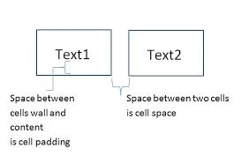

## Colspan and Rowspan Attributes

**colspan** attribute merges two or more columns into a single column. Similar way **rowspan** merges two or more rows.

### Example

<html>

<body>

<table border = "1">

<tr> <th>Column 1</th> <th>Column 2</th> <th>Column 3</th>

</tr>

<tr> <td rowspan = "2">Row 1 Cell 1</td>

<td>Row 1 Cell 2</td> <td>Row 1 Cell 3</td> </tr>

<tr> <td>Row 2 Cell 2</td> <td>Row 2 Cell 3</td> </tr>

<tr> <td colspan = "3">Row 3 Cell 1</td> </tr>

</table> </body> </html>

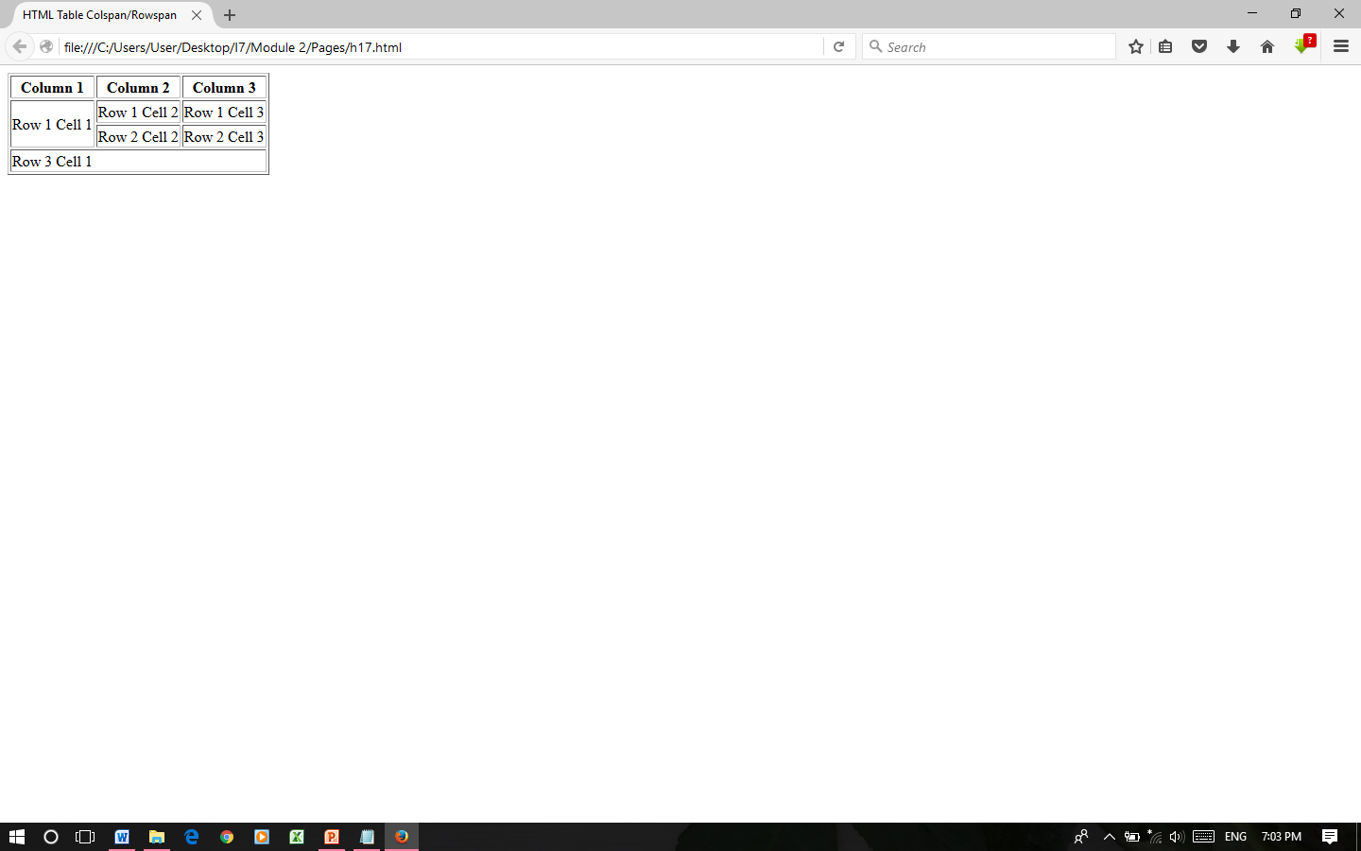

## Tables Backgrounds

You can set table background using one of the following two ways −

**bgcolor** attribute − You can set background color for whole table or just for one cell.

**background** attribute − You can set background image for whole table or just for one cell.

# HTML - Frames

HTML frames are used to divide the browser window into multiple sections where each section can load a separate HTML document. A collection of frames in the browser window is known as a frameset. The window is divided into frames in a similar way the tables are organized: into rows and columns.

## Creating Frames

To use frames on a page we use <frameset> tag instead of <body> tag. The <frameset> tag defines, how to divide the window into frames. The **rows** attribute of <frameset> tag defines horizontal frames and **cols** attribute defines vertical frames. Each frame is indicated by <frame> tag and it defines which HTML document shall open into the frame.

### Example

Following is the example to create three horizontal frames −

<!DOCTYPE html><html>

<frameset rows = "10%,80%,10%">

<frame name = "Left" src = "h8.html" />

<frame name = "Mid" src = "h17.html" />

<frame name = "Right" src = "h7.html" /><noframes>

<body>Your browser does not support frames.</body>

</noframes> </frameset> </html>

# 

<!DOCTYPE html><html>

<frameset cols = "20%,50%,30%">

<frame name = "Left" src = "h8.html" />

<frame name = "Mid" src = "h17.html" />

<frame name = "Right" src = "h7.html" /><noframes>

<noframes>

<body>Your browser does not support frames.</body>

</noframes> </frameset> </html>

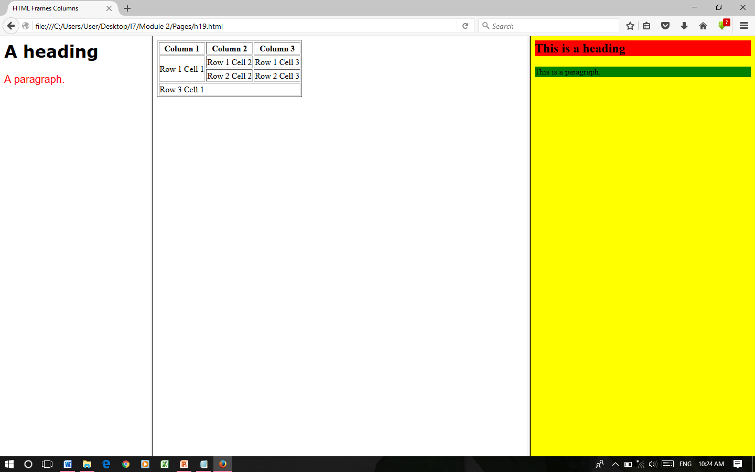

**Disadvantages**

Some smaller devices cannot cope with frames often because their screen is not big enough to be divided up

Sometimes page will be displayed differently on different computers due to different screen resolution.

There are few browsers that do not support frame technology

## The <frameset> Attributes

**Cols :**Specifies how many columns are contained in the frameset and the size of each column. It Can specify the width of each column in one of the four ways

Absolute values in pixels: to create three vertical frames, use cols = "100, 500, 100".

A percentage of the browser window: to create three vertical frames, use cols = "10%, 80%, 10%".

Using a wildcard symbol: to create three vertical frames, use cols = "10%, *, 10%".

As relative widths of the browser window: to create three vertical frames, use cols = "3*, 2*, 1*". (this is an alternative to percentage.)

**Rows**: This attribute works just like the cols attribute and takes the same values, but it is used to specify the rows in the frameset.

to create two horizontal frames, use rows = "10%, 90%".

**Border**: This attribute specifies the width of the border of each frame in pixels. For example, border = "5". A value of zero means no border.

**Frameborder** : This attribute specifies whether a three-dimensional border should be displayed between frames. This attribute takes value either 1 (yes) or 0 (no).

**Framespacing :**This attribute specifies the amount of space between frames in a frameset. This can take any integer value.

For example framespacing = "10" means there should be 10 pixels spacing between each frames.

# The <Frame> Attribute

**Src** : This attribute is used to give the file name that should be loaded in the frame. Its value can be any URL.

src = "/html/h1.htm" will load an HTML file available in html directory.

# Name: This attribute allows you to give a name to a frame. It is used to indicate which frame a document should be loaded into. This is especially important when you want to create links in one frame that load pages into an another frame, in which case the second frame needs a name to identify itself as the target of the link.

**Frameborder :** This attribute specifies whether or not the borders of that frame are shown. It overrides the value given in the frameborder attribute on the <frameset> tag if one is given. this can take values either 1 (yes) or 0 (no).

**Scrolling**: This attribute controls the appearance of the scrollbars that appear on the frame. This takes values either "yes", "no" or "auto". scrolling = "no" means it should not have scroll bars.

**Frame's name and target attributes :** One of the most popular uses of frames is to place navigation bars in one frame and then load main pages into a separate frame.

# HTML iFrame

# You can define an inline frame with HTML tag <iframe>. The <iframe> tag can appear anywhere in your document. The <iframe> tag defines a rectangular region within the document in which the browser can display a separate document, including scrollbars and borders.

# An inline frame is used to embed another document within the current HTML document.

<html>

<body>

<p>Document content goes here...</p>

<iframe src = "h19.html" width = "555" height = "200">

Sorry your browser does not support inline frames.

</iframe>

<p>Document content also go here...</p>

</body>

</html>

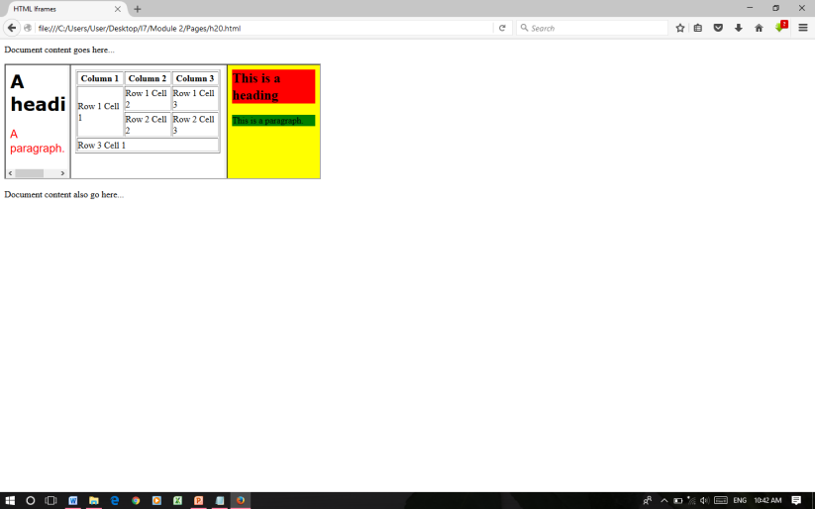

# HTML Lists

HTML Lists are used to specify lists of information. All lists may contain one or more list elements. There are three different types of HTML lists:

1. Ordered List or Numbered List (ol)
2. Unordered List or Bulleted List (ul)
3. Description List or Definition List (dl)

## HTML Ordered List or Numbered List

In the ordered HTML lists, all the list items are marked with numbers. It is known as numbered list also. The ordered list starts with <ol> tag and the list items start with <li> tag.

<ol>

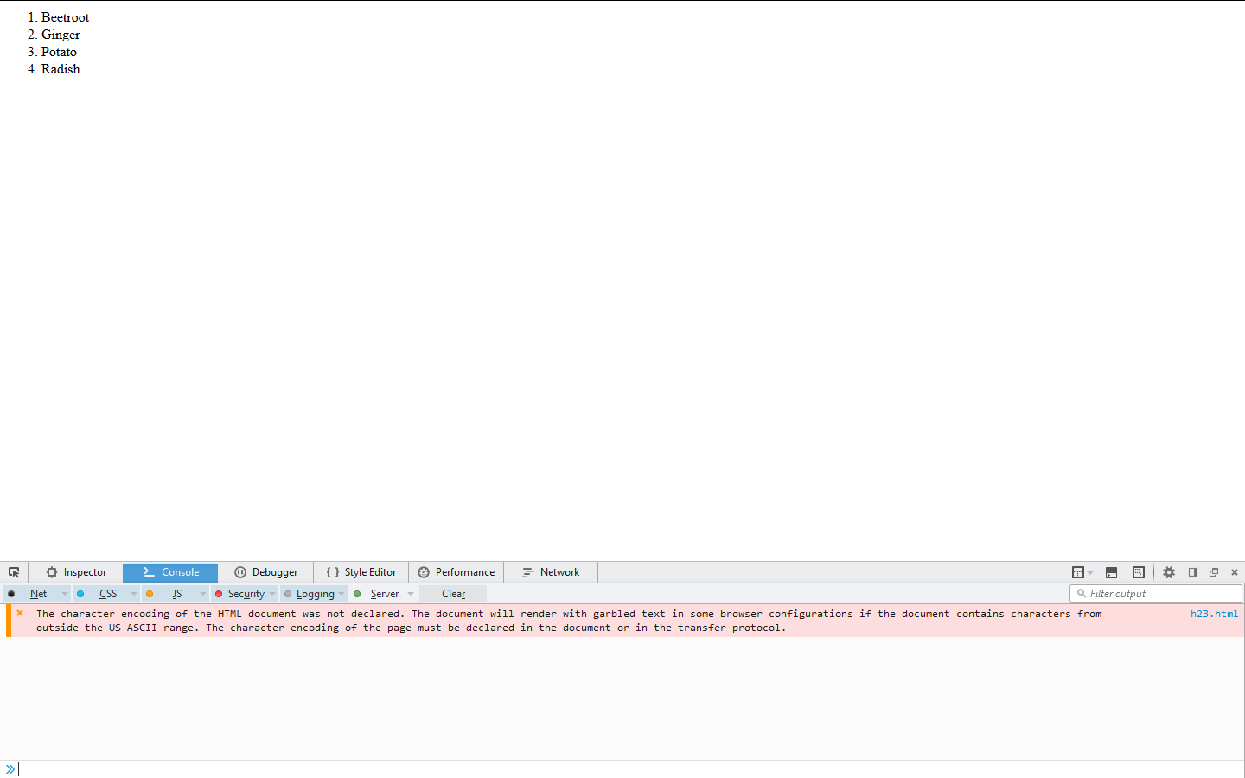 <li>Beetroot</li>

<li>Ginger</li>

<li>Potato</li>

<li>Radish</li>

</ol>

## Ordered HTML List - The Type Attribute

The type attribute of the <ol> tag, defines the type of the list item marker:

|  |  |
| --- | --- |
| **Type** | **Description** |
| type="1" | The list items will be numbered with numbers (default) |
| type="A" | The list items will be numbered with uppercase letters |
| type="a" | The list items will be numbered with lowercase letters |
| type="I" | The list items will be numbered with uppercase roman numbers |
| type="i" | The list items will be numbered with lowercase roman numbers |

**The start Attribute**

You can use start attribute for <ol> tag to specify the starting point of numbering you need. Following are the possible options −

<ol type = "1" start = "4"> - Numerals starts with 4.

<ol type = "I" start = "4"> - Numerals starts with IV.

<ol type = "i" start = "4"> - Numerals starts with iv.

<ol type = "a" start = "4"> - Letters starts with d.

<ol type = "A" start = "4"> - Letters starts with D.

## HTML Unordered List or Bulleted List

In HTML Unordered list, all the list items are marked with bullets. It is also known as bulleted list also. The Unordered list starts with <ul> tag and list items start with the <li> tag.

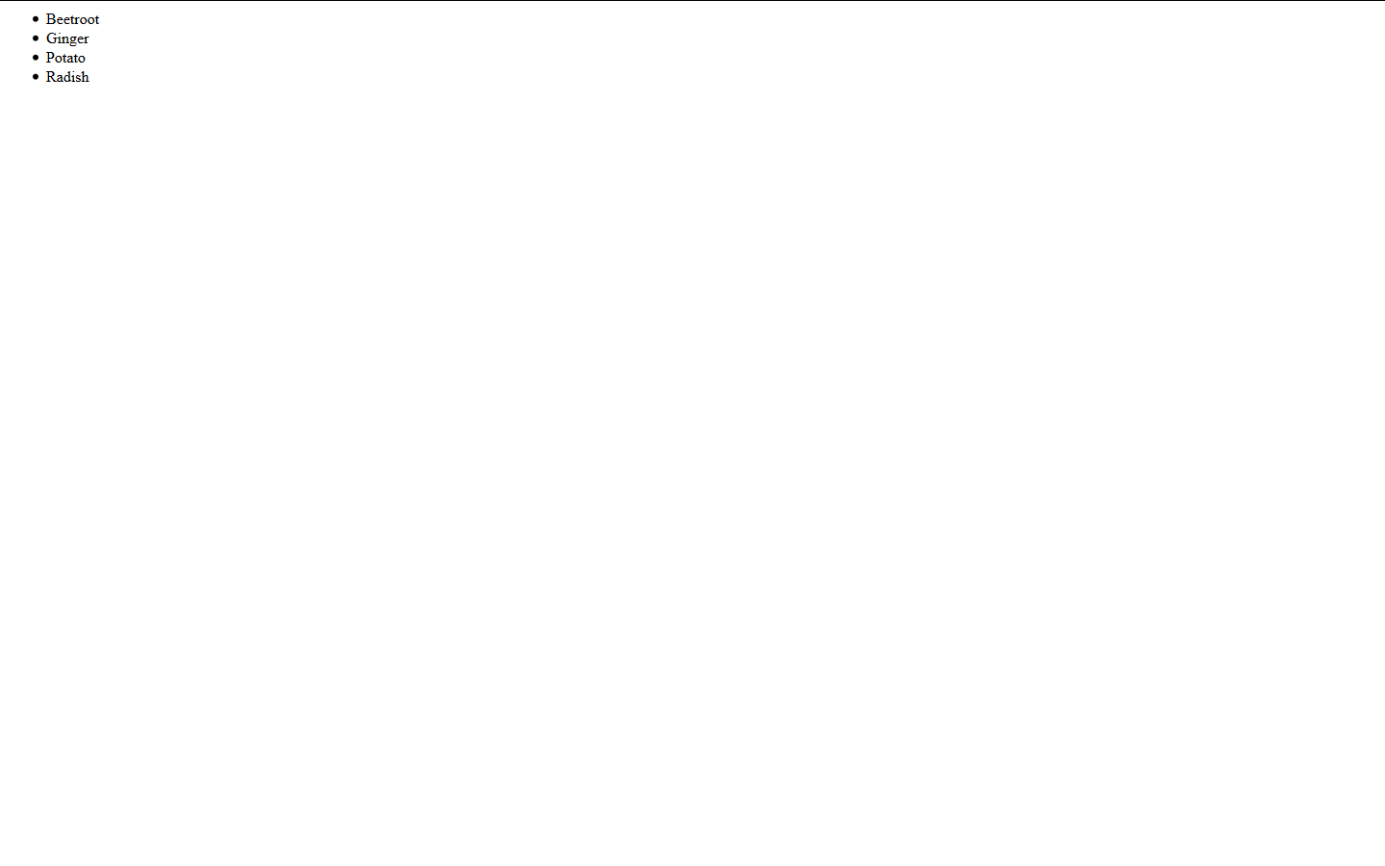<ul>

<li>Beetroot</li>

<li>Ginger</li>

<li>Potato</li>

<li>Radish</li>

</ul>

The CSS list-style-type property is used to define the style of the list item marker or can use type attribute:

|  |  |
| --- | --- |
| **Value** | **Description** |
| Disc | Sets the list item marker to a bullet (default) |
| circle | Sets the list item marker to a circle |
| square | Sets the list item marker to a square |
| none | The list items will not be marked |

### Example - Disc

<ul style="list-style-type:circle">  
  <li>Coffee</li>  
  <li>Tea</li>  
  <li>Milk</li>  
</ul>

## HTML Description List or Definition List

HTML Description list is also a list style which is supported by HTML and XHTML. It is also known as definition list where entries are listed like a dictionary or encyclopedia.

The definition list is very appropriate when you want to present glossary, list of terms or other name-value list.

The HTML definition list contains following three tags:

**<dl> tag** defines the start of the list.

**<dt> tag** defines a term.

**<dd> tag** defines the term definition (description).

**example**

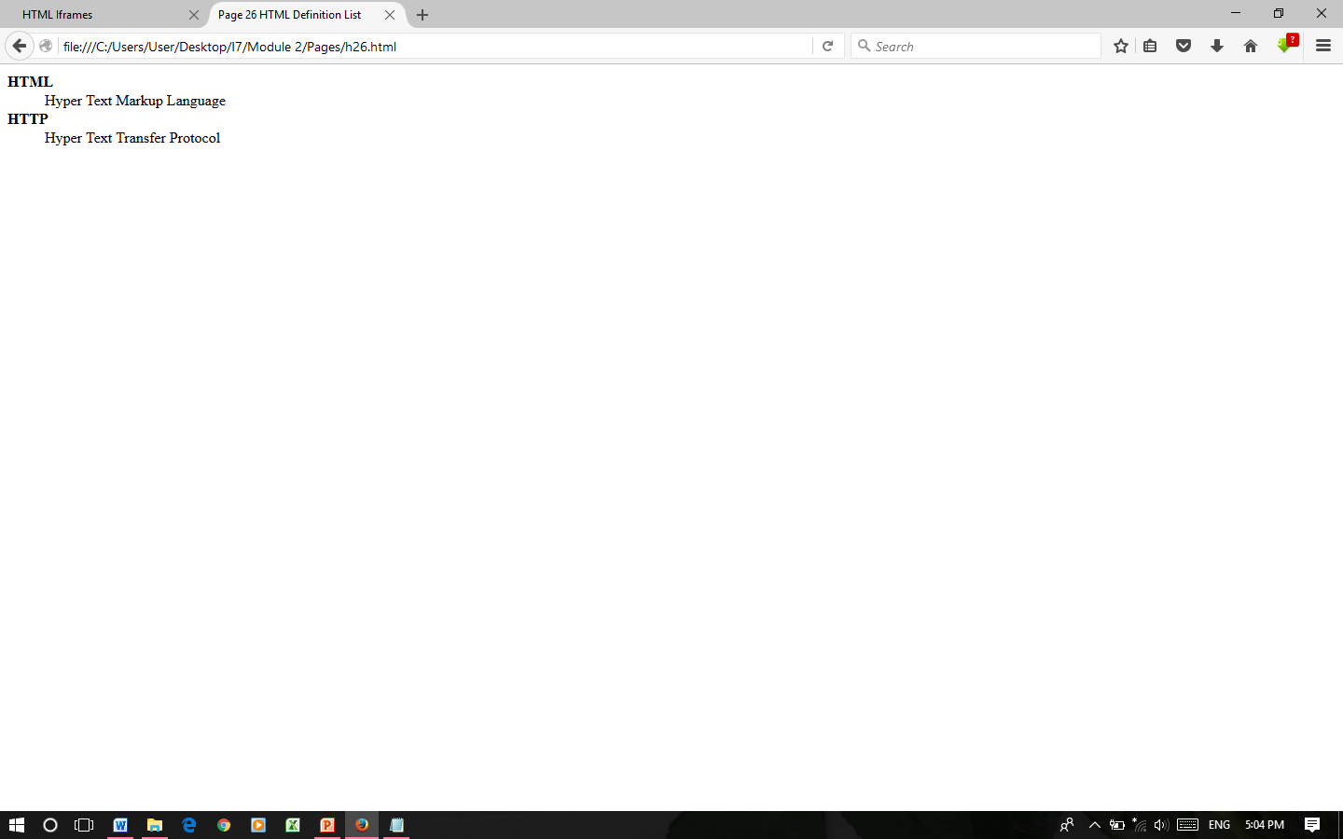 <dl>

<dt><b>HTML</b></dt>

<dd>This stands for Hyper Text Markup Language</dd>

<dt><b>HTTP</b></dt>

<dd> Hyper Text Transfer Protocol</dd>

</dl>

# HTML Forms

# HTML Forms are required, when you want to collect some data from the site visitor. For example, during user registration you would like to collect information such as name, email address, credit card, etc.

## The <form> Element

The HTML **<form>** element defines a form that is used to collect user input:

An HTML form contains **form elements**. Form elements are different types of input elements, like text fields, checkboxes, radio buttons, submit buttons, and more

**The <input> Element**

The <input> element is the most important form element. It can be displayed in several ways, depending on the **type** attribute.

Here are some examples:

|  |  |
| --- | --- |
| **Type** | **Description** |
| <input type="text"> | Defines a one-line text input field |
| <input type="radio"> | Defines a radio button (for selecting one of many choices) |
| <input type="submit"> | Defines a submit button (for submitting the form) |

## Text Input

<input type="text"> defines a one-line input field for **text input**:

<form>  
  First name:<br>  
  <input type="text" name="firstname"><br>  
  Last name:<br>  
  <input type="text" name="lastname">  
</form>

## Password input

This is also a single-line text input but it masks the character as soon as a user enters it. They are also created using HTML <input>tag but type attribute is set to **password**.

<body>

<form >

User ID : <input type = "text" name = "user_id" />

<br>

Password: <input type = "password" name = "password" />

</form>

</body>

## Radio Button Input

<input type="radio"> defines a **radio button**.

Radio buttons let a user select ONE of a limited number of choices:

<form>  
  <input type="radio" name="gender" value="male" checked> Male<br>  
  <input type="radio" name="gender" value="female"> Female<br>  
  <input type="radio" name="gender" value="other"> Other  
</form>

## Button Controls

## There are various ways in HTML to create clickable buttons. You can also create a clickable button using <input>tag by setting its type attribute to button. The type attribute can take the following values −

|  |  |
| --- | --- |
| **Sr.No** | **Type & Description** |
| 1 | **Submit-** This creates a button that automatically submits a form. |
| 2 | **Reset -**This creates a button that automatically resets form controls to their initial values. |
| 3 | **Button-** This creates a button that is used to trigger a client-side script when the user clicks that button. |
| 4 | **Image -**This creates a clickable button but we can use an image as background of the button. |
|  |  |

<body>

<form>

<input type = "submit" name = "submit" value = "Submit" />

<input type = "reset" name = "reset" value = "Reset" />

<input type = "button" name = "ok" value = "OK" />

<input type = "image" name = "imagebutton" src = "img1.jpg" />

</form>

</body>

## Select Box Control

A select box, also called drop down box which provides option to list down various options in the form of drop down list, from where a user can select one or more options.

<form>

<select name = "dropdown">

<option value = "Maths" selected>Maths</option>

<option value = "Physics">Physics</option>

</select>

</form>

**HTML Marquee**

An HTML marquee is a scrolling piece of text displayed either horizontally across or vertically down your webpage depending on the settings. This is created by using HTML <marquees> tag.

Syntax:

<marquee attribute_name = "attribute_value"....more attributes>

One or more lines or text message or image </marquee>

**The <marquee> Tag Attributes**

**Width**: This specifies the width of the marquee. This can be a value like 10 or 20% etc.

**Height**: This specifies the height of the marquee.

**Direction**: This specifies the direction in which marquee should scroll. This can be a value like up, down, left or right.

**Behavior**: This specifies the type of scrolling of the marquee. This can have a value like scroll, slide and alternate.

**Scrolldelay**: This specifies how long to delay between each jump. This will have a value like 10 etc.

**Scrollamount**: This specifies the speed of marquee text. This can have a value like 10 etc.

**Loop**: This specifies how many times to loop. The default value is INFINITE, which means that the marquee loops endlessly.

**Bgcolor**: This specifies background color in terms of color name or color hex value.

**Hspace**: This specifies horizontal space around the marquee.

**Vspace**: This specifies vertical space around the marquee.

**Example**:

<html>

<head>

<title>HTML marquee Tag</title>

</head>

<body>

<marquee behavior="alternate" bgcolor="red"> <b> MARQUEE </b>

</marquee> </br>

<marquee width = "50%" direction="down">This will take only 50% width </marquee>

</body>

</html>

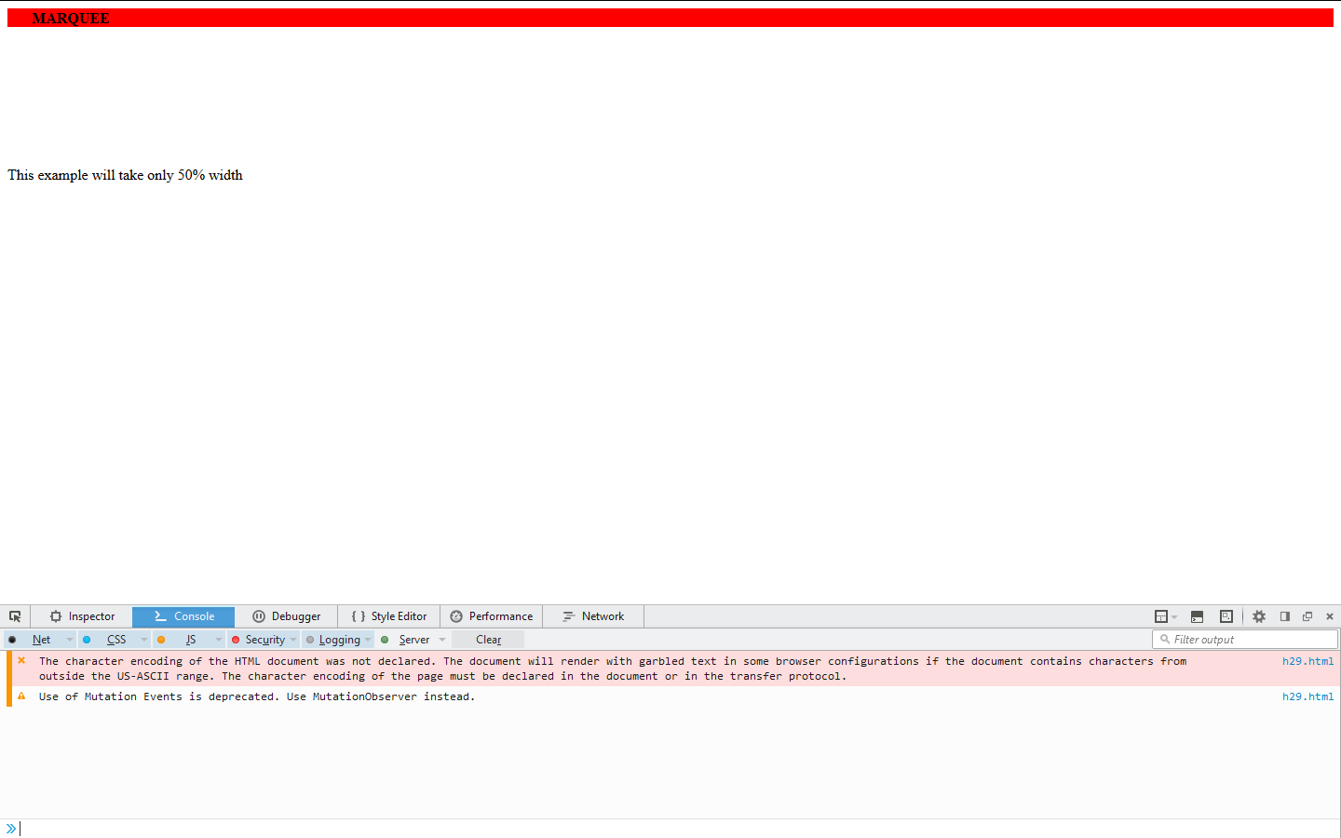

**HTML 5**

HTML5 is a markup language used for structuring and presenting content on the World Wide Web. It is the fifth and latest major version of HTML that is a World Wide Web Consortium (W3C) recommendation. The current specification is known as the HTML Living Standard and is maintained by a consortium of the major browser vendors (Apple, Google, Mozilla, and Microsoft), the Web Hypertext Application Technology Working Group (WHATWG).

HTML5 was first released in public-facing form on 22 January 2008 with a major update and "W3C Recommendation" status in October 2014. Its goals were to improve the language with support for the latest multimedia and other new features; to keep the language both easily readable by humans and consistently understood by computers and devices such as web browsers, parsers, etc., without XHTML's rigidity; and to remain backward-compatible with older software. HTML5 is intended to subsume not only HTML 4 but also XHTML 1 and DOM Level 2 HTML.

HTML5 includes detailed processing models to encourage more interoperable implementations; it extends, improves and rationalizes the markup available for documents and introduces markup and application programming interfaces (APIs) for complex web applications. For the same reasons, HTML5 is also a candidate for cross-platform mobile applications, because it includes features designed with low-powered devices in mind.

HTML5 is a next version of HTML. Some brand new features which will make HTML much easier. These new introducing features make your website layout clearer to both website designers and users. There are some elements like <header>, <footer>, <nav> and <article> that define the layout of a website.

**New APIs**

In addition to specifying markup, HTML 5 specifies scripting application programming interfaces (APIs) that can be used with JavaScript. Existing Document Object Model (DOM) interfaces are extended and de facto features documented. There are also new APIs, such as:

Canvas;

Timed Media Playback;

Offline;

Editable content

Drag and drop;

History;

MIME type and protocol handler registration;

Microdata;

Web Messaging;

Web Storage – a key-value pair storage framework that provides behaviour similar to cookies but with larger storage capacity and improved AP

## Why use HTML5

It is enriched with advance features which makes it easy and interactive for designer/developer and users.

* It allows you to play a video and audio file.
* It allows you to draw on a canvas.
* It facilitate you to design better forms and build web applications that work offline.
* It provides you advance features for that you would normally have to write JavaScript to do.

## List of HTML 5 Tags

|  |  |
| --- | --- |
| **Tag** | **Description** |
| <article> | This element is used to define an independent piece of content in a document that may be a blog, a magazine or a newspaper article. |
| <aside> | It specifies that article is slightly related to the rest of the whole page. |
| <audio> | It is used to play audio file in HTML. |
| <bdi> | The bdi stands for bi-directional isolation. It isolates a part of text that is formatted in other direction from the outside text document. |
| <canvas> | It is used to draw canvas. |
| <data> | It provides machine readable version of its data. |
| <datalist> | It provides auto complete feature for textfield. |
| <details> | It specifies the additional information or controls required by user. |
| <dialog> | It defines a window or a dialog box. |
| <figcaption> | It is used to define a caption for a <figure> element. |
| <figure> | It defines a self-contained content like photos, diagrams etc. |
| <footer> | It defines a footer for a section. |
| <header> | It defines a header for a section. |
| <main> | It defines the main content of a document. |
| <mark> | It specifies the marked or highlighted content. |
| <menuitem> | It defines a command that the user can invoke from a popup menu. |
| <meter> | It is used to measure the scalar value within a given range. |
| <nav> | It is used to define the navigation link in the document. |
| <progress> | It specifies the progress of the task. |
| <rp> | It defines what to show in browser that doesn’t support ruby annotation. |
| <rt> | It defines an explanation/pronunciation of characters. |
| <ruby> | It defines ruby annotation along with <rp> and <rt>. |
| <section> | It defines a section in the document. |
| <summary> | It specifies a visible heading for <detailed> element. |
| <svg> | It is used to display shapes. |
| <time> | It is used to define a date/time. |
| <video> | It is used to play video file in HTML. |
| <wbr> | It defines a possible line break. |

# HTML Audio Tag

**HTML audio tag** is used to define sounds such as music and other audio clips. Currently there are three supported file format for HTML 5 audio tag.

1. mp3
2. wav
3. ogg

HTML5 supports <video> and <audio> controls. The Flash, Silverlight and similar technologies are used to play the multimedia items.

# HTML Video Tag

HTML 5 supports <video> tag also. The HTML video tag is used for streaming video files such as a movie clip, song clip on the web page.

Currently, there are three video formats supported for HTML video tag:

1. mp4
2. webM
3. ogg